Report 3

# Tasks:-

**Task 1: Your today’s lab first task is to study and practice following debug commands. Submit a report on what is the purpose of each debug command along with examples of possible formats in which they can be used.**

1. **Fill**
2. **Proceed**
3. **Search**
4. **Exchange**
5. **Fill(f)**

Fills addresses in the specified memory area with values you specify.

**Syntax:-** **f** *range list*

**Parameters:-**

***Range*:** Required. Specifies the starting and ending addresses, or the starting address and length, of the memory area you want to fill.

***List:*** Required. Specifies the data you want to enter.

**?:** Displays a list of **debug** subcommands.

**Examples:-**

* 1. **F 100 500,’ ’**

Type upper command

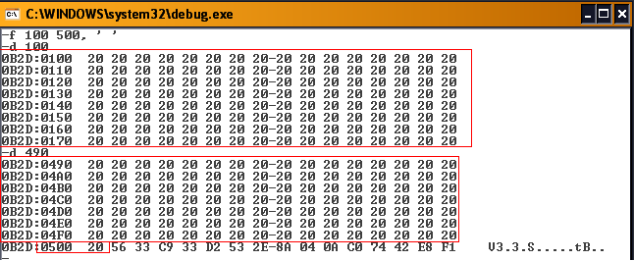

**Result:-** Fill with spaces from 100 to 500.

* 1. **F CS:300 1000,FF**

Type upper command

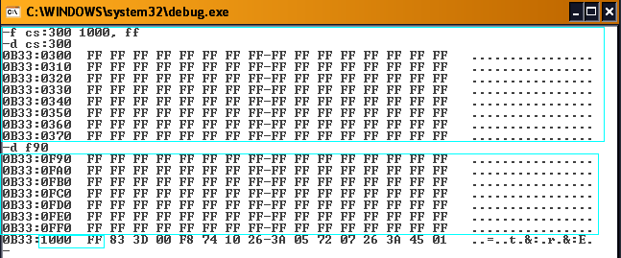

**Result:-** Fill with hex FF from 300 to 1000.

* 1. **F 100 L 20 ‘A’**

Type upper command

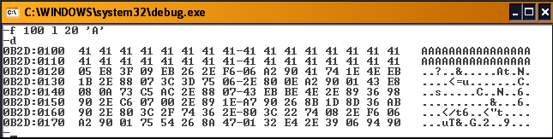

**Result:-** Fill 20h bytes with the letter ‘A’, starting at location 100.

## Proceed (P)

The p command executes one or more instructions or subroutines. Whereas the T (trace) command traces into subroutine calls, the P command simply executes subroutines. Also, LOOP instruction and string primitive instructions (SCAS, LODS, etc) are executed completely up to the instruction that follows them. Command format:

P

P = address

P = address number

Examples are:

|  |  |
| --- | --- |
| **Examples** | **Description** |
| P = 200 | Execute a single instruction at CS:0200 |
| P = 150 6 | Execute 6 instructions starting at CS:0150 |
| P 5 | Execute the next 5 instruction |

**Example: - debugging a Loop.** Let’s look at an example where the P command steps through MOV and ADD instruction one at a time. When the P command reaches the LOOP instruction, however, the complete loop is executed five times:

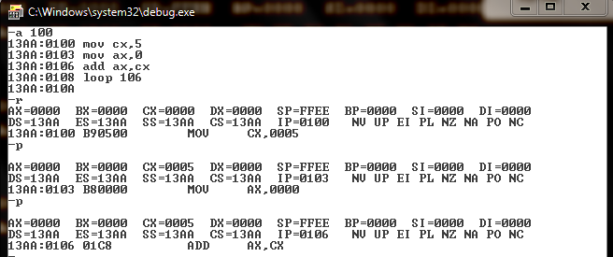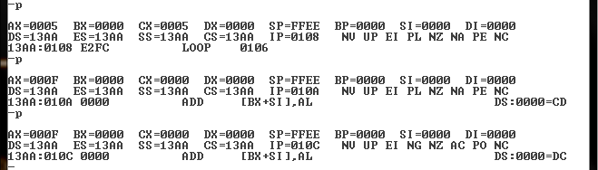

## Search (S)

The S command searches a range of addresses for a sequence of one or more bytes. The command format is:

S *range list*

Here are some examples

|  |  |
| --- | --- |
| **Examples** | **Comment** |
| S 100 1000 0D | Search DS:100 to DS:1000 for the value ODh. |
| S 100 1000 CD,20 | Search for the sequence CD 20. |
| S 100 9FFF “COPY” | Search for the word “COPY” |

## Exchange (EX)

Exchanges the contents of two registers.

**Syntax:** XCHG op1, op2

**Example:**

xchg ax, bx ;exchange BX with AX

# Q2: Practice and demonstrate with example how Loop and Jump commands can be used.

## LOOP Instruction

LOOP instruction provides a simple way to repeat a block of statements a specific number of times.

CX is automatically used as a counter and is decremented each time the loop repeats.

**Termination Condition:** CX =0

**Example:**

a 100

mov cx,5

mov ax,0

add ax,cx

loop 106

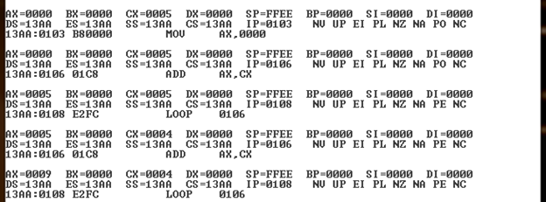

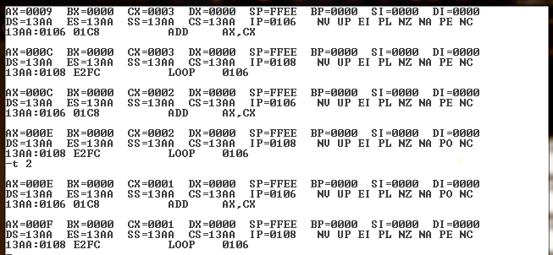

Now cx = 0000, loop terminated

**Note:-** this example I use Trace(t) command. If u want to check result using Proceed(p) command goto **b. proceed (p)** and see **Example: - debugging a Loop.**

## JMP Instruction

The JMP instruction causes an unconditional transfer to the target location inside the code segment.

The location must be indentified by a code label.

JMP *targetlabel*

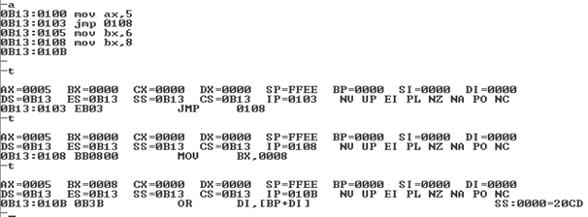

(mov bx,6) command is not execute because jmp 0108 jump it to 0B13:0108 command i.e., mov bx,8.